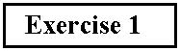

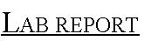

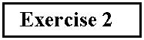

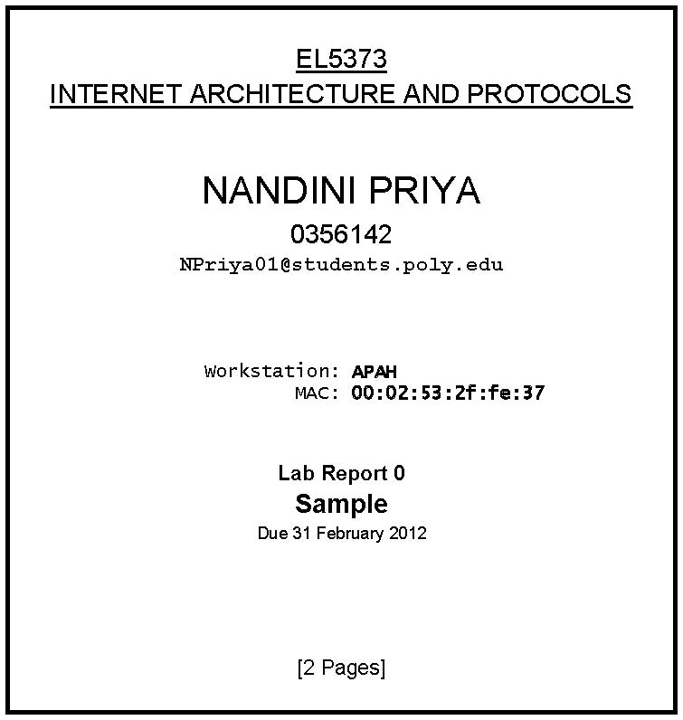

EL5373 (e-Poly) Internet Architecture and Protocols

Sample Lab Exercise / Report
Please save paper by not printing this document

Note: This Document contains a SAMPLE exercise and a SAMPLE Lab Report for it. This exercise as such cannot be done in the actual Lab Session.

Running tcpdump on your host, telnet to a remote host and log in to it using the password given. Can you log into the remote host?

From the tcpdump output, which port on the remote host was used for the telnet connection?

What was the sequence number of the first telnet packet?

Using the route command, observe the routing table for your host. Save the output of the command for your Lab Report.

How many different routes did you see in the routing table?

The following pages contain the SAMPLE Lab Report for the above SAMPLE Exercises.

Exercise 1

Port number used on remote host is 23.

Sequence Number of first telnet packet is 23451.

Exercise 2

There were two routes in the routing table.

